**JANE WAY**

-----**CAPITAL**-----

LOGO

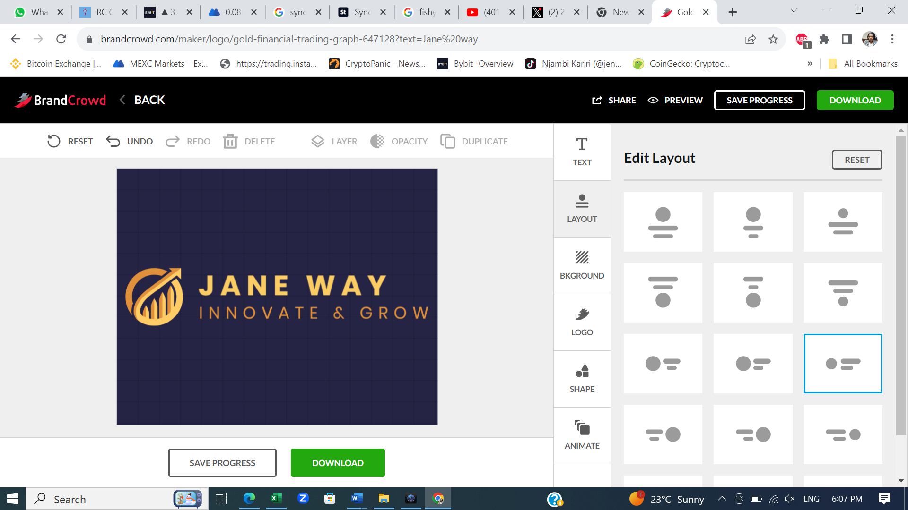

Business Card

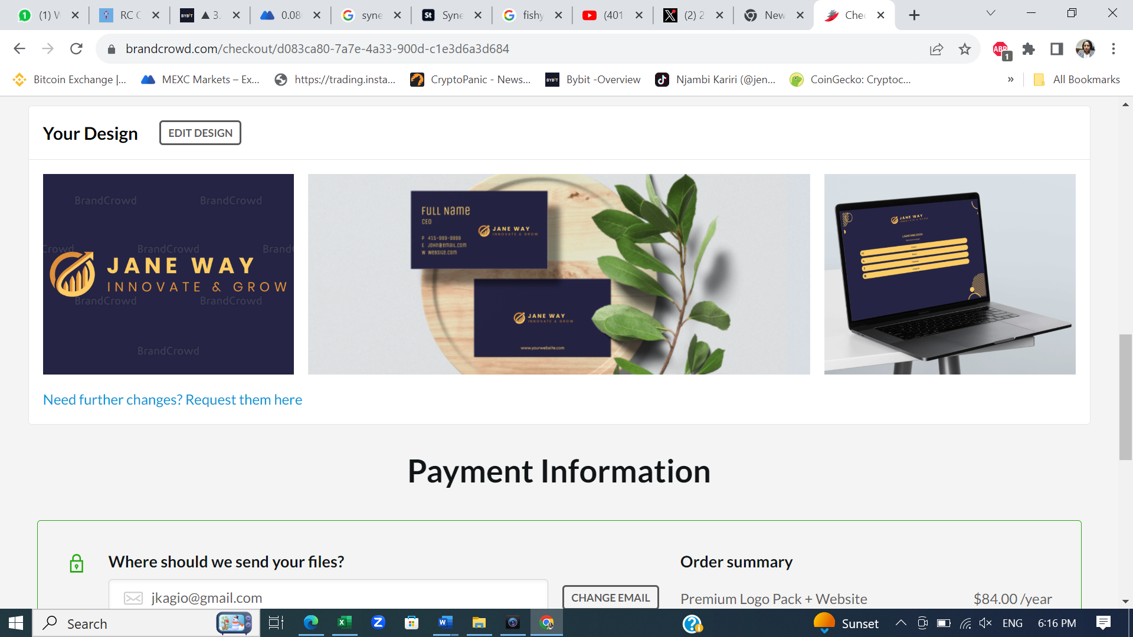

Letter Head

**WHO WE ARE**

Founded by a small group of traders, researchers, and technologists in Nairobi / Abu Dabi in 2023.

We trade a broad range of asset classes though specialize in disruptive technology assets.

We revenge on innovation in tech to carry out our core business that is functional trading to give success and growth to our clients.

**OUR VALUES**

**HONESTY AND TRANSPARENCY**

We are a team that shares common values of honesty and transparency. We disclose all the risks and cost that comes with expected rewards.

**RESPONSIBLE RISK MANAGEMENT.**

Trading and Investing involves a lot of risk assessment and management, the reason why active risk management at a core task in our business. We dive dip into analyzing inherent risk of every asset and how wider markets risk impacts of our assets. We take responsibility for any failure on our processes and take them as a learning opportunity to improve them.

**INTELLECTUAL CURIOSITY**

Constantly updating our knowledge base, unlearning the outdated ways and assumptions, and learning new innovative ways of doing business.

**TEAMWORK, CONSULTATION AND COLLABORATION.**

A flat team made of Partners, working together towards a shared goal.

**OUR teams**

##### **TRADING AND RESEARCH**

The trading and research teams are blended to develop profitable trading strategies, signals, and execution methods. Most of our trading involves strategies that are developed jointly by a mix of traders and researchers.

Trading requires fast, high-stakes decision making, and that is done mainly by traders. On the other hand, researchers take on trading that requires strategies that take months to develop and optimize.

By combining this differentiated trading expertise, plus market knowledge, and a deep understanding of the needs of our investors, we help them achieve their trading goals.

##### **INNOVATIVE TECHNOLOGY**

Technology is the heart of everything we do. Our software engineers use the most innovative technology to write code as part of their day-to-day work. This gives us our in-house software tools that improve productivity, accuracy, and real-time data displays.

By applying the most innovative and advanced tools available, we drive growth and success for our investors.

##### **BACK OFFICE / OPERATIONS**

Our operations team forms the backbone of our company by keeping the day-to-day operations running seamlessly. They manage all our corporate affairs matters including finance and administration, legal and compliance matters, and project management.

#### **OUR SERVICES**

##### **INVESTIMENTS, TRADING AND RESEARCH**

We are an investment, trading and research company that uses a blend of strategies including functional trading and market research to give consistent growth and returns on investments.

With the new technology in decentralization and especially Decentralized Finance (Defi), regardless of location, we are able to trade securely, continuously and seamlessly in all the global markets.